**Industrial Internship Report on**

**”CURRENCY CONVERTER”**

**Prepared by**

**[Mukesh Mahato Dhanuk]**

|  |
| --- |
| *Executive Summary* |
| This report provides details of the Industrial Internship provided by upskill Campus and The IoT Academy in collaboration with Industrial Partner Uni Converge Technologies Pvt Ltd (UCT).  This internship was focused on a project/problem statement provided by UCT. We had to finish the project including the report in 6 weeks’ time.  My project was about simple currency convertor. The **Simple Currency Converter** was created using only **Python** programming language. This application is a user-friendly kind of application that can easily fit to your needs. The application is operational and can be use to convert any currency in the market. This can you to know the current currency value of your money. The application use an api that track the changes of the currency in the market To operate this application you just to need to run this code in a python compiler.  This internship gave me a very good opportunity to get exposure to Industrial problems and design/implement solution for that. It was an overall great experience to have this internship. |

**TABLE OF CONTENTS**

1 Preface 3

2 Introduction 8

2.1 About Currency Converter 8

2.2 About upskill Campus 15

2.3 Objective 16

2.4 Reference 17

3 Problem Statement 18

4 Existing and Proposed solution 22

5 Proposed Design/ Model 24

6 Performance Test 25

6.1 Performance Outcome 26

7 My learnings 28

8 Future work scope 30

# Preface

Summary of the whole 6 weeks’ work.

We work on simple currency convertor. We learn about the big O data and other data and information. we learned about the introduction of data science and machine learning in first week. In week 2 we we follow the project instructions & plan and solution. In week 3 ,we learned about the AI VS DATA Science, Probability and statistics and started to work on project. In week 4,we learned about machine learning and continuous work & check for improvements of our project . In week 5,we learned about success Leader To the Corporate world, salary of the data engineer. We perform, implement and test our code for currency converter. In week 6 ,we make reprository on github and post our code and final report there.

About need of relevant Internship in career development.

Relevant internships play a crucial role in career development for individuals, especially students and young professionals. They offer numerous benefits and can significantly enhance one's chances of success in the job market. Here are some reasons why relevant internships are essential for career development:

1. Practical Experience:

Internships provide an opportunity to gain practical, hands-on experience in a specific field or industry. This real-world exposure complements theoretical knowledge acquired in classrooms and helps bridge the gap between academic learning and practical application.

1. Skill Development:

Internships allow individuals to develop and hone essential skills required in their chosen profession. These skills may include communication, teamwork, problem-solving, time management, and industry-specific technical skills.

1. Networking Opportunities:

During internships, individuals interact with professionals, colleagues, and mentors within the industry. Building a network of contacts can open doors to future job opportunities and provide valuable guidance and support in career advancement.

1. Resume Enhancement:

Having relevant internships on a resume demonstrates practical experience and commitment to a specific career path. It sets candidates apart from those who have only academic qualifications but lack hands-on experience.

1. Career Clarity:

Internships help individuals gain a better understanding of their chosen career path. It allows them to test the waters, assess their interests and skills, and determine if the field aligns with their long-term career goals..

Brief about my project/problem statement.

Problem Statement:

The goal of this project is to develop a user-friendly and efficient currency converter application. The currency converter should be able to convert between different currencies based on real-time exchange rates and provide accurate results to the users. The application should be accessible via a web interface or a mobile app, allowing users to conveniently perform currency conversions on the go.

Key Features:

1. Real-time Exchange Rates:

The currency converter should fetch real-time exchange rates from reliable sources or APIs to ensure accuracy in conversions.

1. User-friendly Interface:

The application should have an intuitive and easy-to-navigate interface, allowing users to input the amount they wish to convert and select the source and target currencies effortlessly.

1. Multiple Currency Support:

The currency converter should support a wide range of currencies, including major international currencies and popular cryptocurrencies.

1. Customizable Settings:

Provide options for users to customize decimal places, rounding methods, and display preferences according to their preferences.

Challenges:

1. Data Source Reliability:

Ensuring the currency converter fetches exchange rates from a trustworthy and up-to-date data source is critical to maintaining accuracy.

1. Real-time Updates:

Implementing a mechanism to keep the exchange rates up to date in real-time without causing performance issues for users can be challenging.

1. Handling High Traffic:

The application must handle a potentially large number of simultaneous users performing currency conversions, necessitating efficient server management.

Success Criteria:

The success of the currency converter will be evaluated based on the following criteria:

1. Accuracy:

The currency converter should provide precise conversion results, reflecting real-time exchange rates.

1. User Satisfaction:

Positive user feedback and ease of use will indicate a successful application.

1. Reliability:

The application should consistently fetch and display up-to-date exchange rates without downtime or data source errors.

Opportunity given by USC/UCT.

How Program was planned



My Learnings and overall experience.

I experience many things while I was doing our internship. I faced a lot of problems but I overcome that all problems. I took the help of youtube and also from senior.

Thank to all ( Ujjawal Kumar Thakur, MD Shahnawaz Alam), who have helped you directly or indirectly.

My message to my juniors and peers.

While doing internship problems comes but don’t leave the internship due to obstacles. you can take help from yours senior.

# Introduction

## 2.1 About Currency Converter:

A currency converter is a handy tool that enables individuals and businesses to convert the value of one currency into another based on prevailing exchange rates. It serves as a crucial financial instrument for those dealing with international trade, travel, or investment, as it allows them to quickly and accurately calculate the equivalent value of their money in a foreign currency. Currency converters play a vital role in simplifying global financial transactions and ensuring smooth cross-border interactions.

The need for currency conversion arises due to the existence of multiple currencies worldwide. Each country has its own official currency, and its value is constantly changing in response to various economic and geopolitical factors. Exchange rates, which represent the relative value of one currency compared to another, fluctuate continuously, affecting the purchasing power and financial outcomes for individuals and businesses engaged in international activities.

The primary function of a currency converter is to provide real-time or up-to-date exchange rate information and facilitate instant conversions between different currencies. Typically, currency converters are available as web-based tools on financial websites, as built-in features in financial applications. Users can input the amount they want to convert, select the source and target currencies, and receive the converted value almost instantaneously.

Currency converters rely on reliable data sources, such as central banks, financial institutions, or reputable exchange rate APIs, to ensure the accuracy of their results. Real-time exchange rate data is crucial to provide users with precise and reliable conversion values.

In conclusion, a currency converter is an indispensable tool in today's globalized world, facilitating seamless currency conversions and enabling efficient financial transactions across borders. Whether it's for business purposes, travel planning, or personal financial management, currency converters empower users to navigate the complexities of international currencies with ease and confidence.  

A factory platform for currency convertor

A factory platform for a currency converter refers to a centralized system infrastructure designed to handle the operations and functionalities of a currency converter. This platform serves as the backbone of the currency converter, managing its core features, data processing, and interactions with users and external data sources.

Key Components and Features of the Factory Platform for a Currency Converter:

1. Data Integration:

The platform should incorporate mechanisms to connect with reliable data sources that provide real-time exchange rates for various currencies. These data sources can include financial institutions, central banks, or reputable exchange rate APIs. The platform must ensure the continuous and secure flow of data from these sources.

1. Exchange Rate Management:

The factory platform should handle the storage, updating, and management of exchange rate data. It needs to regularly fetch the latest exchange rate information from the integrated sources and maintain historical data for analytical purposes.

1. User Management:

The platform should have user authentication and management functionalities to handle user registrations, login credentials, and account preferences. This is especially important if the currency converter offers personalized features such as saved conversion history or customized settings.

1. Currency Support:

The factory platform must accommodate a comprehensive list of currencies from different countries and regions. It should allow administrators to manage the supported currencies easily and add new ones as needed.

1. API Integration (Optional):

If the currency converter is part of a larger financial ecosystem or serves as a service for other applications, the factory platform may include API endpoints to enable seamless integration with external systems.

1. Analytics and Reporting (Optional):

For business and monitoring purposes, the platform might incorporate analytics and reporting tools to track user activity, conversion trends, and other relevant data.

By providing a robust and scalable factory platform, developers can efficiently build and maintain a feature-rich currency converter application that meets the needs of its users while ensuring accurate and real-time currency conversions.

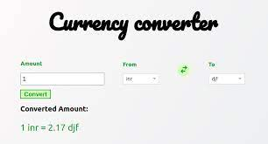 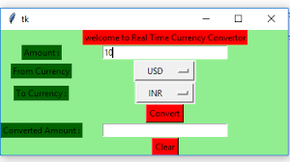

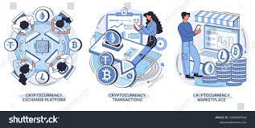

1. Based Solution

A currency convertor is one of the based solution for converting currency of any country with other country. It helps people to save their time.

1. Predictive Maintenance

Predictive maintenance is an advanced maintenance strategy that utilizes data analytics and machine learning techniques to predict and prevent potential issues before they occur. Applying predictive maintenance to a currency converter software can help improve its reliability, performance, and user experience. Here's how predictive maintenance can be implemented for a currency converter application:

1. Data Collection:

- Gather relevant data from the currency converter software, including user interactions, conversion history, error logs, and performance metrics.

- Additionally, collect data from external sources, such as exchange rate APIs, to monitor changes in real-time exchange rates.

2. Data Preprocessing:

- Clean and preprocess the collected data to remove inconsistencies, handle missing values, and prepare it for analysis.

3. Anomaly Detection:

- Use anomaly detection algorithms to identify abnormal patterns or deviations from normal behavior within the software's performance and user interactions.

- Anomalies may indicate potential issues or errors that could affect the accuracy of currency conversions or impact user experience.

4. Performance Metrics Monitoring:

- Monitor key performance metrics of the currency converter, such as response time, conversion success rate, and server load, to identify performance degradation or unusual patterns.

5. Proactive Maintenance:

- Based on the predictions from the machine learning models and anomaly detection, schedule proactive maintenance activities to prevent potential failures or issues.

- For example, if the system predicts a possible slowdown due to increased server load, a maintenance window can be scheduled to optimize server resources.

6. Continuous Monitoring and Improvement:

- Continuously monitor the currency converter’s performance and user interactions to keep the predictive maintenance system up to date.

- Collect feedback from users to identify areas for improvement and to enhance the accuracy of the predictive maintenance models.

By implementing predictive maintenance techniques, the currency converter can proactively address potential issues, ensure smooth currency conversions, and provide a seamless user experience. Predictive maintenance helps reduce downtime, improve system reliability, and optimize resource utilization, ultimately leading to greater user satisfaction and efficiency in currency conversion operations.

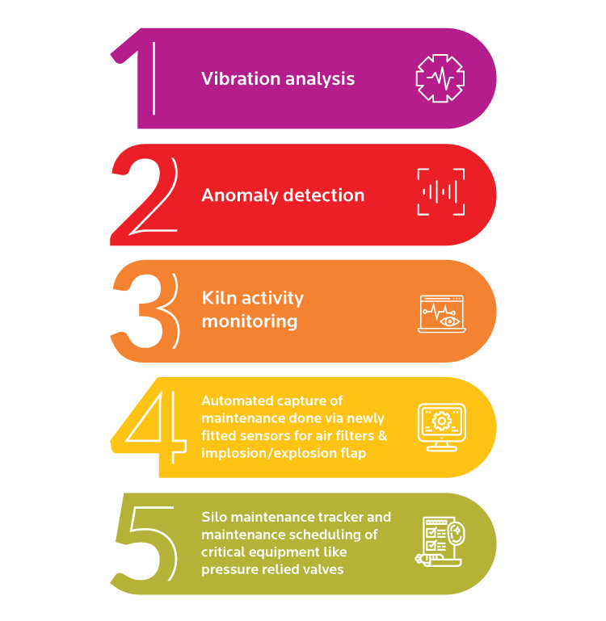

## 2.2 About upskill Campus (USC)

upskill Campus along with The IoT Academy and in association with Uniconverge technologies has facilitated the smooth execution of the complete internship process.

USC is a career development platform that delivers **personalized executive coaching** in a more affordable, scalable and measurable way.



Seeing need of upskilling in self paced manner along-with additional support services e.g. Internship, projects, interaction with Industry experts, Career growth Services

<https://www.upskillcampus.com/>

upSkill Campus aiming to upskill 1 million learners in next 5 year

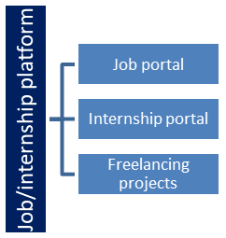

## The IoT Academy

The IoT academy is EdTech Division of UCT that is running long executive certification programs in collaboration with EICT Academy, IITK, IITR and IITG in multiple domains.

## Objectives of this Internship program

The objective for this internship program was to

 ☛ get practical experience of working in the industry.

 ☛ to solve real world problems.

 ☛ to have improved job prospects.

 ☛ to have Improved understanding of our field and its applications.

 ☛ to have Personal growth like better communication and problem solving.

## Reference

[1] http://currencyapi.com

[2] Book:- Python Programming Blueprints by Daniel Furtado and Marcus Pennington

# Problem Statement

In the assigned problem statement

The problem statement of a currency converter revolves around the need to create an efficient and accurate software application or tool that allows users to convert the value of one currency into another based on real-time exchange rates. The primary objective is to simplify and streamline currency conversion for individuals, businesses, and travelers who frequently engage in international financial transactions or require foreign currency equivalents for various purposes.

Key Components of the Problem Statement:

1. Real-Time Exchange Rates:

The currency converter should provide users with up-to-date and accurate exchange rates sourced from reliable data providers. Real-time exchange rates are crucial as currency values fluctuate continuously due to various economic and geopolitical factors.

1. User-Friendly Interface:

The currency converter application should have an intuitive and user-friendly interface that allows users to input the amount they want to convert and easily select the source and target currencies.

1. Currency Support:

The currency converter should support a wide range of currencies from different countries and regions. Major international currencies and popular cryptocurrencies should be included to meet the diverse needs of users.

4. Accuracy and Precision:

The core functionality of the currency converter lies in accurately and precisely calculating the converted value based on the selected currencies and real-time exchange rates. The solution should deliver precise results to ensure financial transactions are conducted without errors.

5.Performance:

The currency converter should be efficient and responsive, providing fast conversion results even during peak usage times. Performance is critical to delivering a seamless user experience.

6. Historical Data (Optional):

Optionally, the currency converter may include historical exchange rate data, enabling users to track currency trends over time and conduct historical financial analyses.

Challenges:

Developing an effective currency converter comes with several challenges, including:

- Sourcing reliable real-time exchange rate data from trusted providers.

- Implementing robust error handling to address potential issues that may arise during data retrieval or conversion calculations.

- Handling currency conversions involving exotic or less commonly used currencies for which data might be less readily available.

- Ensuring the security of user data and protecting against potential threats in financial transactions.

Success Criteria:

The success of the currency converter solution will be measured based on the following criteria:

1. Accuracy: The currency converter should provide precise and reliable conversion results based on real-time exchange rates.

2. User Satisfaction: Positive user feedback and ease of use indicate a successful application that meets users' needs.

3. Performance: The currency converter should respond quickly and efficiently, even under heavy user traffic.

4. Currency Support: The application should support a wide range of currencies to accommodate diverse user requirements.

5. Reliability: The currency converter should maintain uptime and provide consistent access to real-time exchange rate data.

6. Security: Ensuring the security of user data and financial transactions is essential for user trust and confidence in the application.

# Existing and Proposed solution

Proposed Solution for Currency Converter Project:

1. Frontend Development:

- Design a user-friendly and responsive web or mobile interface for the currency converter application. The UI should allow users to input the amount, select source and target currencies, and display the converted value

2. Backend Development:

- Develop the backend of the application using a suitable programming language and framework. Python with Django can be used.

- Implement APIs to fetch real-time exchange rate data from reliable sources. Consider using free or paid APIs that offer up-to-date exchange rates.

3. Exchange Rate Data:

- Integrate with a reputable exchange rate API that provides real-time and accurate currency exchange rate data. Popular APIs include Open Exchange Rates, Fixer, or currencylayer.

4. Currency Conversion Logic:

- Implement the core currency conversion logic based on the fetched exchange rates. The application should accurately calculate the converted amount.

5. Historical Data (Optional):

- If desired, set up a database to store historical exchange rate data periodically fetched from the API. This allows users to view historical trends and conduct financial analysis.

6. Continuous Updates and Maintenance:

- Regularly update exchange rate data, perform software updates, and monitor application performance to ensure the currency converter remains functional and up-to-date.

Please note that the specific details and technologies used in the proposed solution may vary based on the development team's preferences, requirements, and the scale of the project. Additionally, for a real-world implementation, legal considerations, data usage policies, and licensing terms of the chosen exchange rate API should be taken into account.

## Code submission (https://github.com/mahatomukesh/Upskill_Campus/tree/master/code)

## Report submission (https://github.com/mahatomukesh/Upskill_Campus/blob/master/Currency%20Converter_Mukesh%20Mahato%20Dhanuk_USC_UCT.docx)

# Proposed Design/ Model

Designing a currency converter involves creating a system that allows users to convert between different currencies based on current exchange rates. Below is a proposed design model for a currency converter application:

1. Currency Exchange Rate Data:

The currency converter will require access to up-to-date exchange rate data. There are various options to achieve this, such as using a third-party API that provides exchange rate information or integrating with a reliable financial data provider.

2. Currency Conversion Logic:

The currency conversion logic should be able to calculate the converted amount based on the entered value and the exchange rate between the selected currencies. Here's a simple formula for the conversion:

Converted Amount = Entered Amount * Exchange Rate

3. Real-time Exchange Rate Updates:

To ensure accuracy, the application should update exchange rates regularly, especially if there are frequent fluctuations in currency values. Implementing an automatic update mechanism will be essential to maintain up-to-date exchange rate information.

# Performance Test

Performance testing of a currency converter is essential to ensure that the application can handle a significant number of users and conversions without performance degradation. The primary goal is to identify any bottlenecks or issues that might affect the application's response time and scalability. Here's an outline of the performance testing process:

1. Define Performance Metrics:

Determine the key performance metrics you want to measure, such as response time, throughput (transactions per second), server CPU and memory usage, network latency, and database performance.

2. Real-Time Exchange Rate Updates:

Include performance testing scenarios that involve real-time exchange rate updates. Test how well the system handles fetching and updating the exchange rates from external sources.

3. Performance Analysis and Optimization:

During testing, monitor the performance metrics and collect performance data. Analyze the data to identify any performance bottlenecks. Common areas to optimize include database queries, API calls, and caching mechanisms.

4. Performance Reporting:

Prepare a comprehensive performance testing report that includes the test results, performance metrics, identified issues, and recommendations for improvements.

Keep in mind that performance testing should be an ongoing process, especially when deploying new updates or changes to the currency converter application. Regular performance testing helps maintain optimal performance and ensures a smooth user experience even as the user base grows.

## Performance Outcome

The actual performance outcomes will depend on various factors, such as the application's design, infrastructure, server capacity, network conditions, and the number of concurrent users. Below are some expected performance outcomes for a well-optimized currency converter:

1. Response Time:

The currency converter should have fast response times for currency conversions. For small to moderate user loads, the response time should be in milliseconds or a few seconds at most.

1. Throughput:

The project should handle a high throughput of currency conversion requests per second. The specific throughput will depend on the server capacity and the complexity of the currency conversion logic. It should be able to handle hundreds or even thousands of conversions per second.

1. Real-time Exchange Rate Updates:

The project should efficiently fetch and update exchange rates from external sources without causing delays in conversions or impacting overall performance.

1. Memory Usage:

The project's memory usage should be reasonable and not cause excessive memory consumption or memory leaks over time.

1. Load Handling:

The currency converter should handle peak loads without significantly impacting response times or causing server overload.

It's important to note that achieving optimal performance requires continuous monitoring and periodic performance testing, especially as user traffic and requirements evolve over time. Additionally, the actual performance outcomes may vary depending on the specific implementation and infrastructure used for the currency converter.

# My learnings

As this is my first internship in Data science and machine learning I was not knowing so much about Data Science and Machine learning but after doing this internship I came to know about Impact of Big Data On Business, Data Scientist, Data Analyst, AI, Probability and Statistics, Machine Learning etc.

Data science and machine learning have become crucial fields in the modern job market, and they offer various ways to facilitate career growth. Here are some ways data science and machine learning can help in career advancement:

1. Increased Demand for Data Skills:

With the growing importance of data-driven decision-making, organizations across industries are seeking professionals with data science and machine learning expertise. Having these skills makes you more valuable to employers, increasing your chances of landing better job opportunities.

1. Higher Earning Potential:

Data science and machine learning roles are often well-compensated due to their high demand and specialized nature. As my gain experience and expertise, my learning potential is likely to increase significantly.

1. Career Progression:

The skills and knowledge acquired in data science and machine learning can accelerate my career progression. As I tackle simple projects and demonstrate tangible results, I may qualify for promotions or higher-level roles.

1. Problem-Solving Abilities:

Data science and machine learning focus on solving real-world problems using data-driven insights. Developing strong problem-solving skills in these areas can be beneficial in various aspects of my career.

5. Continuous Learning:

Data science and machine learning are rapidly evolving fields. Staying up-to-date with the latest trends and technologies requires continuous learning, which fosters personal and professional growth.

In summary, data science and machine learning skills offer significant advantages for career growth, including increased demand, higher earning potential, and entrepreneurship. Continuous learning and a proactive approach to skill development will further enhance my career prospects in these dynamic and evolving fields.

# Future work scope

Relevant internships play a crucial role in career development for individuals, especially students and young professionals. They offer numerous benefits and can significantly enhance one's chances of success in the job market. Here are some reasons why relevant internships are essential for career development:

1. Practical Experience:

Internships provide an opportunity to gain practical, hands-on experience in a specific field or industry. This real-world exposure complements theoretical knowledge acquired in classrooms and helps bridge the gap between academic learning and practical application.

1. Skill Development:

Internships allow individuals to develop and hone essential skills required in their chosen profession. These skills may include communication, teamwork, problem-solving, time management, and industry-specific technical skills.

1. Networking Opportunities:

During internships, individuals interact with professionals, colleagues, and mentors within the industry. Building a network of contacts can open doors to future job opportunities and provide valuable guidance and support in career advancement.

1. Resume Enhancement:

Having relevant internships on a resume demonstrates practical experience and commitment to a specific career path. It sets candidates apart from those who have only academic qualifications but lack hands-on experience.

5.Career Clarity:

Internships help individuals gain a better understanding of their chosen career path. It allows them to test the waters, assess their interests and skills, and determine if the field aligns with their long-term career goals.

6.Confidence Building:

Completing internships successfully can boost self-confidence and instill a sense of accomplishment, which is essential for personal and professional growth.

1. Job Placement:

In some cases, companies use internships as a way to identify potential future employees. If an intern performs well, they may be offered a full-time position upon graduation.

In conclusion, relevant internships are instrumental in career development as they offer practical experience, skill development, networking opportunities, and increased employability. Students and young professionals should actively seek out internships that align with their career goals to maximize their growth and potential for success in their chosen fields.